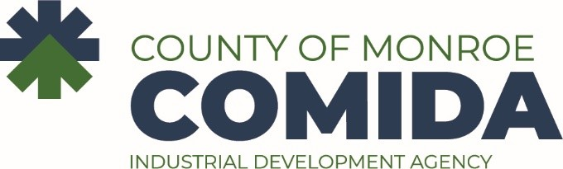

COMPLIANCE COMMITTEE MINUTES
December 18, 2023

Time & Place: 2:00 p.m. at City Place, 50 West Main Street

Board Present: A. Burr, J. Alloco, L. Bolzner, T. Milne

Also Present: R. King, R. Finnerty, R. Baranello, Esq., A. Clark

The meeting of the Compliance Review Committee was called to order by A. Burr Chair at 2:02 p.m.

On motion by T. Milne, second by J. Alloco, all aye, minutes of the September 6, 2023 committee meeting were approved.

Staff shared updated from the four projects for which the committee asked for additional information.

After discussion, on motion by J. Alloco, second by L. Bolzner, all aye, the committee recommends the full board grant a job creation waiver for project code 2602 11 030 A.

After discussion, on motion by J. Alloco, second by L. Bolzner, all aye, the committee recommends the full board grant a job creation waiver for project code 2602 14 036 A.

After discussion, on motion by T. Milne, second by J. Alloco, all aye, the committee recommends the full board grant a job creation waiver for project code 2602 18 062 M.

Staff will continue conversations with the host municipality on project code 2602 16 067 A.

There being no other business to discuss, on motion by L. Bolzner, second by J. Alloco, the meeting was adjourned at 2:33B p.m.

